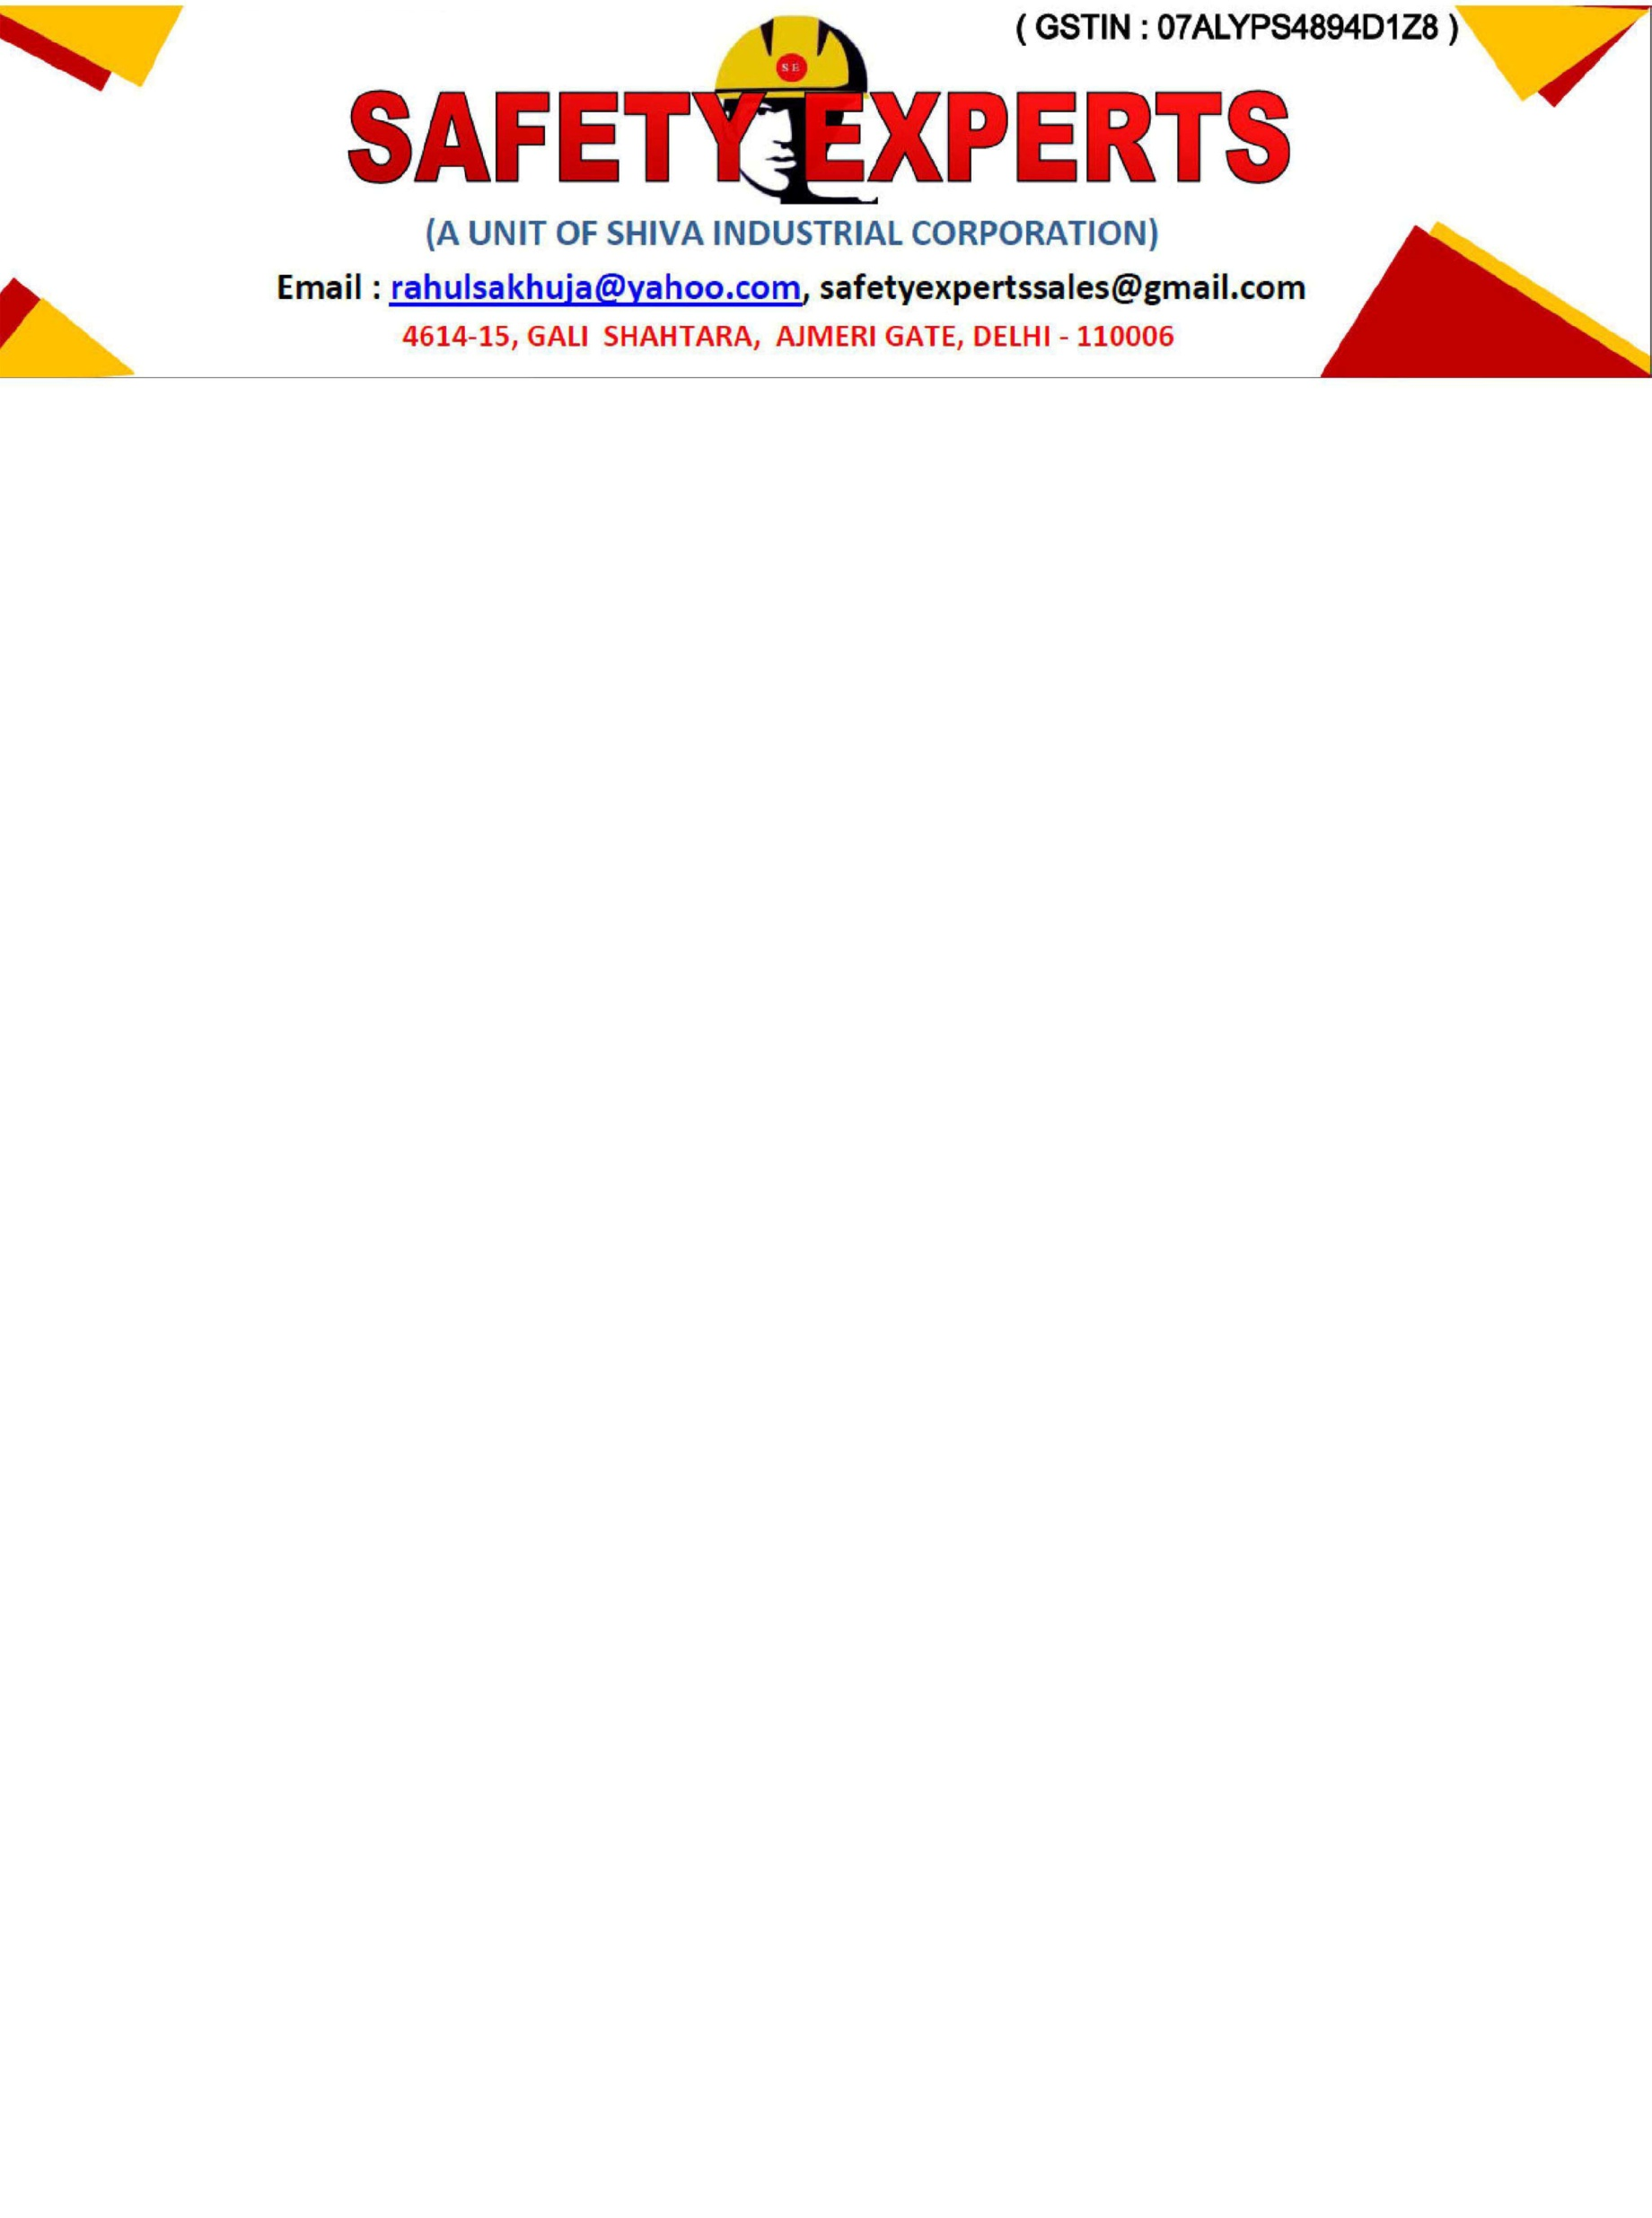

COMPANY PROFILE

YOUR SAFETY OUR PRIORITY

- M/s. Safety Experts was set up in the year 2002 under the able guidance of our Director Mr. Rahul Sakhuja who has been an excellent guiding force for the Company and its employees. The Company was set up with one and only ambition to provide best products in the field of Safety.

- Life is Crucial hence it has to be protected by providing best Safety Products at the workplace and that is the goal of the company.

- It is our aspiration in SAFETY EXPERTS to provide the best solutions in the field of Fire, Road, Surgical & Industrial Safety. Safety Experts is one stop for personal protective equipment. Providing Solutions from Head to Toe. We look forward to work with your in a way that strengthens our relationship based on trust for lifetime.

- SAFETY EXPERTS are the leading Manufacturer of Safety Items under :
- Unisafe Brand Free Fall Brand Supercure Brand
PPE’s Fall Protection Surgical Gloves
Industrial Workwear Rope Ladder Nitrile Exam Gloves
Road Safety Fire Blankets Surgical Disposable Products
Lockout Tagout
Helmets
Distributors & Exporters of well known brands of India in the field of industrial Safety Personal Protective,Fire & Road Safety Equipments. We still stand strong to deliver the best service with renowned quality Products.

- We have a wide range of products which consist of Safety Helmets, Safety Goggles, Face Sheild, Ear Plugs & Ear Muffs,Safety Hand Gloves, Body Protection Suits, Fire & Heat Protective Clothings, Respiratory Protection, Safety Shoes,Fall Protection, Alluminium Safety Ladders, Construction Safety Nets, Protection against Industrial Hazards, Welding Curtains & Fire Blankets, Emergency Safety Shower, Emergency Eyewashes, Industrial Fabrics & Technical Textiles, Road Safety Products, Fire Fighting Products, Security Products, Lockout Tagout Products, Industrial Lifting Equipments.

- We Supply all products manufactured as per Indian and International Standards.

- We are authorized dealer of Duckback Brand Rainsuit, Raincoat & Gumboots.

